INVENTION DISCLOSURE FORM
Confidential & Attorney-Client Privileged

Applicant Name SR University
Applicant Address: Ananthsagar, Hasanparthy (M), Warangal Urban, Telangana - 506371,

- Particulars of Inventors

Mr./Ms/Dr. | Name (Full) | Department | Designation | Mobile No. | Email | Postal Address
Mr. | Naresh Kumar Sripada | CS&AI | Asst. Professor | 9866000203 | Naresh22.in@gmail.com | SR University, Ananthasagar Hanamkonda
Mr. | Surya Teja Keerthi | CS&AI | Student | 9290129483 | keerthisuryateja2005@gmail.com | SR University, Ananthasagar Hanamkonda
Ms. | Vrindha Bijjala | CS&AI | Student | 7416029606 | bijjalavrindha7@ gmail.com | SR University, Ananthasagar Hanamkonda
Ms. | Siri Chandana Boga | CS&AI | Student | 7993805841 | bogasirichandana08@gmail.com | SR University, Ananthasagar Hanamkonda
Ms. | Akshaya Thakur | CS&AI | Student | 7799335155 | akshayasingh0222@gmail.com | SR University, Ananthasagar Hanamkonda

- Provide a brief descriptive title of the invention:
CSP-Guard: AI-Based Context-Aware Code Safety and Copy-Paste Risk Analyzer

- In 100 words or less, please provide an abstract or summary of the invention:
The CSP-Guard is an automated security system which employs artificial intelligence to identify potentially dangerous code reuse due to copy-paste actions in software programming. Contrary to the conventional cloning mechanisms that only emphasize the comparison based on syntax, CSP-Guard utilizes the Execution Context Delta Model in determining the semantic differences between the source and destination environments. The system assesses various aspects such as variable usage, scope, exception handling, tainting, and resource access to come up with a multiple risk assessment score.

- Detail description of the invention:( Answer to all below are required in detail)

  - Problem the invention is solving
Code reuse via copy and paste poses certain risks like: Context inconsistency (incompatible variables, scopes) Security weaknesses (such as SQL injection attacks) Lack of error-handling routines Complexity of maintenance Current techniques can only identify similarity but cannot determine whether the reused code will be secure when used in a new environment.

  - General Utility/application of the invention
IDE integration (VS code extension) Pipeline tools for automated risk assessment
Security-first software development Help with code reviews Enterprise security audit

  - Advantages of the invention disclosing about the increased efficiency/efficacy
Identifies hidden weaknesses overlooked by conventional software
Offers contextual analysis, not mere syntax comparison
False positives rare (only 2.1%)
Immediate feedback enhances coding efficiency
Decreases maintenance expenses and debugging time

  - Best way of using the invention as well as possible variants
Best Usage:
Integrated into IDE for real-time alerts during coding
Used in CI/CD for automated scanning

Variants:
Language-specific models (Python, Java, JS)
Cloud-based analysis system
Lightweight version for small projects
Advanced version with runtime (dynamic) analysis

  - Working of invention along with Drawing, schematics and flow diagrams if required with complete explanations
Working of CSP-Guard System

The CSP-Guard framework works via a systematic multi-phase pipeline that analyzes and identifies the problem of unsafe code reuse resulting from copy-paste activities. The entire process is explained using the Pipeline Flow Diagram, Component Architecture Diagram, and Risk Scoring Graph.

Pipeline Flow Diagram
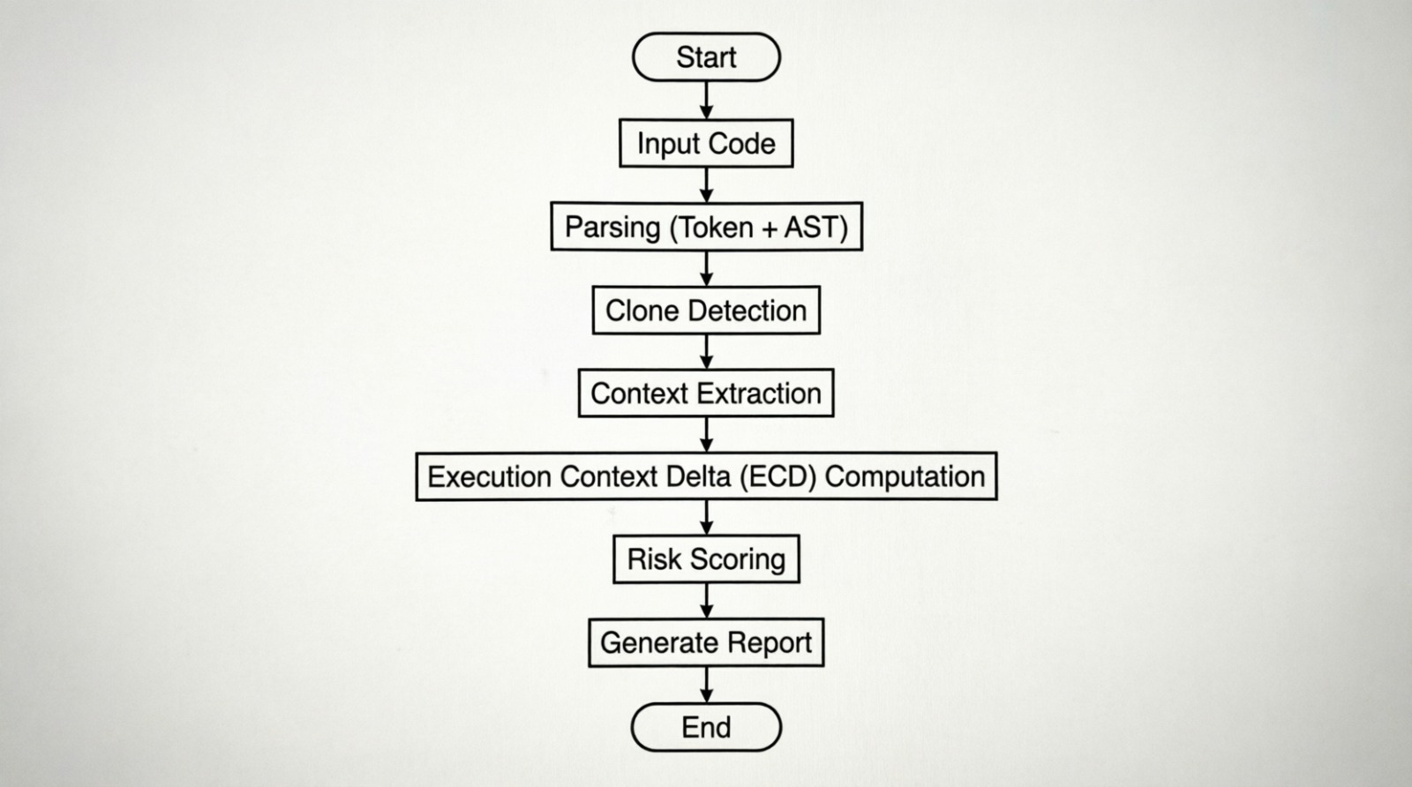

This diagram illustrates the complete workflow of the CSP-Guard system from input to output. It shows sequential stages such as code input, parsing, clone detection, context extraction, ECD computation, and risk scoring. Arrows indicate the flow of data between each stage. The visual helps in understanding how the system processes code step-by-step.

Execution Context Delta (ECD) Component Architecture Diagram
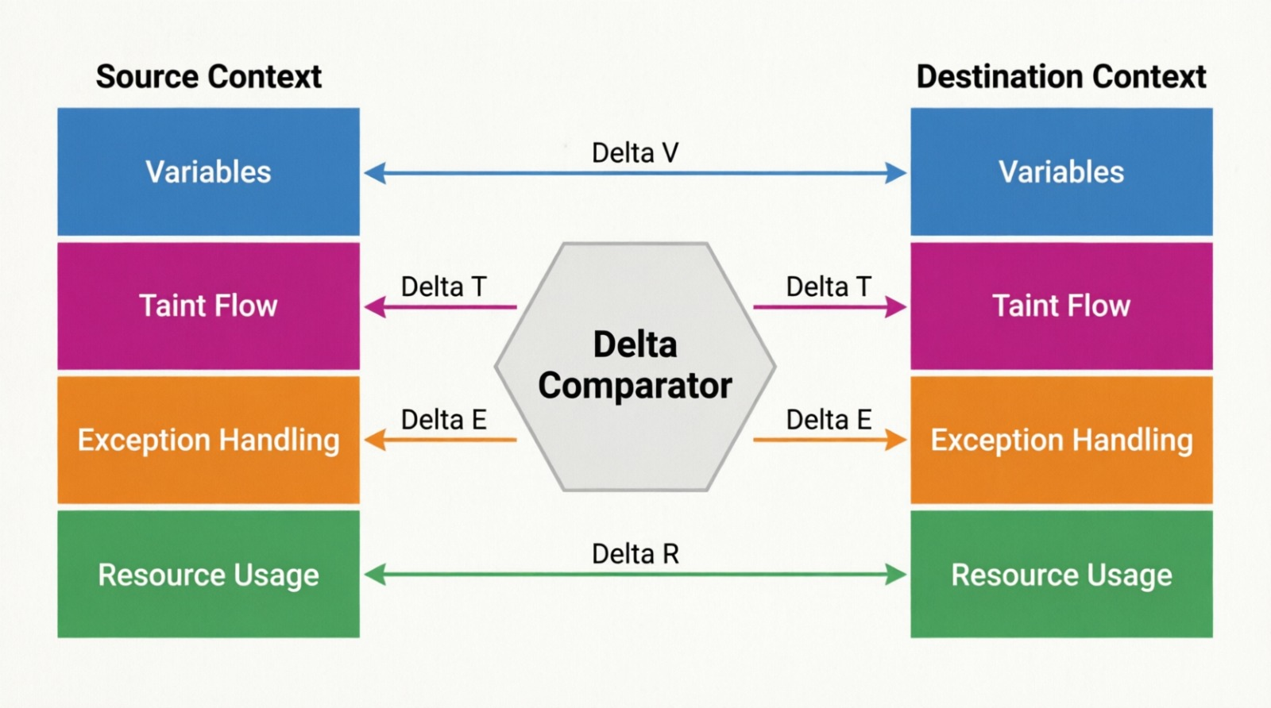This diagram illustrates the Execution Context Delta (ECD) comparison between source and destination code environments. It compares key factors such as variables, taint flow, exception handling, and resource usage. The Delta Comparator computes differences (ΔV, ΔT, ΔE, ΔR) to identify inconsistencies. These differences are used to assess the risk associated with code reuse.

Step 1: Code Input and Parsing

The system takes the input code base provided by the user using the IDE plugin or CI/CD pipeline. The input is parsed via the parser module (Tree-based Parsing), which converts the source code into structured forms such as tokens and Abstract Syntax Trees (AST).

This structured representation enables deeper analysis beyond plain text comparison.

Step 2: Clone Detection

During this phase, the system determines the presence of similar code snippets that could have been duplicated. Clone detection is accomplished via a hybrid similarity approach, incorporating token similarity, AST structural similarity, and data flow similarity. Code snippets whose similarity exceeds a pre-specified threshold are considered for cloning.
Step 3: Context Extraction

For every clone pair identified, the following information regarding the execution context will be extracted from the source code as well as the destination code. Variables (type, scope, and mutability), scope bindings (local scope, global scope, and closures), exception handlers, taint sources and sinks (such as user inputs, APIs, and databases), and resource usage (including files, locks, and connections) are all analyzed. This entire process is carried out by the Context Extractor module within the system architecture.

Step 4: Execution Context Delta (ECD) Computation

The primary novelty of the invention resides in this stage. The system analyzes the execution context of the source and destination program segments and evaluates the Execution Context Delta (ECD). This highlights important dissimilarities, including variable inconsistencies, lack of error handling routines, presence of unsafe input data (taint), and disputes over resources. The resulting differences are then represented in terms of divergence scores.
(Refer to Pipeline Flow Diagram – ECD Computation)

Step 5: Risk Scoring Mechanism

The composite risk score is calculated for each set of context differences based on a probabilistic algorithm. As the degree of context differences becomes higher, the risk score also rises. The Risk Score Graph illustrates how risk correlates with context divergence and categorizes it into levels such as Safe, Low Risk, Medium Risk, and High Risk. This approach ensures that even minor but critical differences, particularly those related to security, have a significant impact on the final risk assessment.

Step 6: Output Generation and Recommendations

Lastly, the tool provides an output report that includes the risk score and its classification, explanations of the identified issues, highlighted differences in the code, and recommended solutions such as input validation and proper exception handling. This output is delivered in real time within the development environment or integrated into automated CI/CD pipelines.

- Have you conducted Primary Patent Search? Yes / No (if yes, attach the patent search report)
Yes
(Based on literature review of clone detection tools like SourcererCC, NICAD, CodeQL, Semgrep)

- Existing state-of-the-art and prior arts: (Brief background of the existing knowledge/product/process in the market)
Tools for detecting clones such as SourcererCC and NICAD, static code analysis tools like Semgrep and CodeQL, and deep learning-based vulnerability detection systems including VulDeePecker and VUDENC primarily focus on code structure or predefined patterns. However, they do not incorporate context-aware analysis to evaluate whether the code is safe within its specific usage environment.

- List out the known ways about how others have tried to solve the same or similar problems? Indicate the disadvantages of these approaches. In addition, please identify any prior art documentation or other material that explains or provides examples of such prior art efforts.

S. No. | Existing state of art | Drawbacks in existing state of art | Overcome (how your invention is overcoming the drawback)
1 | Clone Detection Tools | Only detect similarity | CSP-Guard analyzes context safety
2 | Static Analysis Tools | No copy-paste awareness | CSP-Guard links cloning + risk
3 | ML-based detectors | Black-box, no explanation | CSP-Guard gives interpretable risk
4 | Security scanners | Pattern-based only | Context-aware dynamic risk scoring

- List the Technical features and Elements of the invention along with the Description of your invention from Clone start to end.
Detection Engine (Token + Abstract Syntax Tree + Data Flow) Execution Context Extractor ECD Comparator Risk Scoring Engine Report Generator

Flow:
Input Code → Clone Detection → Context Extraction → ECD → Risk Score → Report

- List out the features of your invention which are believed to be new and distinguish them over the closest technology.
Execution Context Delta Model Risk Assessment Using Multiple Dimensions Context-Based Analysis of Clone Safety Combination of Syntax, Semantics, and Security

- Has the invention been built or tested or implemented? If so, please provide the particulars of the first time it was successfully built or implemented (when, where, by whom, and evidence of this event including written or on-line pointers to documentary evidence):All testing details
This invention has been successfully implemented and made into a functional prototype named CSP-Guard in the year 2026 at SR University by the inventors. This system was designed as an interactive application with a user-friendly interface that allows users to input source and destination code fragments for analysis. The full functionality of the system, including clone detection, execution context extraction, Execution Context Delta (ECD) computation, and risk assessment, was implemented and tested.

The initial successful implementation involved real-world code reuse scenarios. In one representative case, a database query function was copied from a secure context, where integer input was properly validated, into an insecure context that used raw string input from an HTTP request. The system accurately detected taint introduction (ΔT ≈ 98%), variable type mismatch (ΔV ≈ 85%), and the risk of SQL injection. It assigned a risk score of 0.43, classifying the case as Medium Risk, and recommended mitigation strategies such as using parameterized queries.

Several additional test cases were also executed, including scenarios with missing exception handling, safe code reuse cases (true negatives), and variable type mismatches. The overall results demonstrate that the system effectively identifies context-based risks and provides meaningful, actionable feedback to developers.

Evidence:
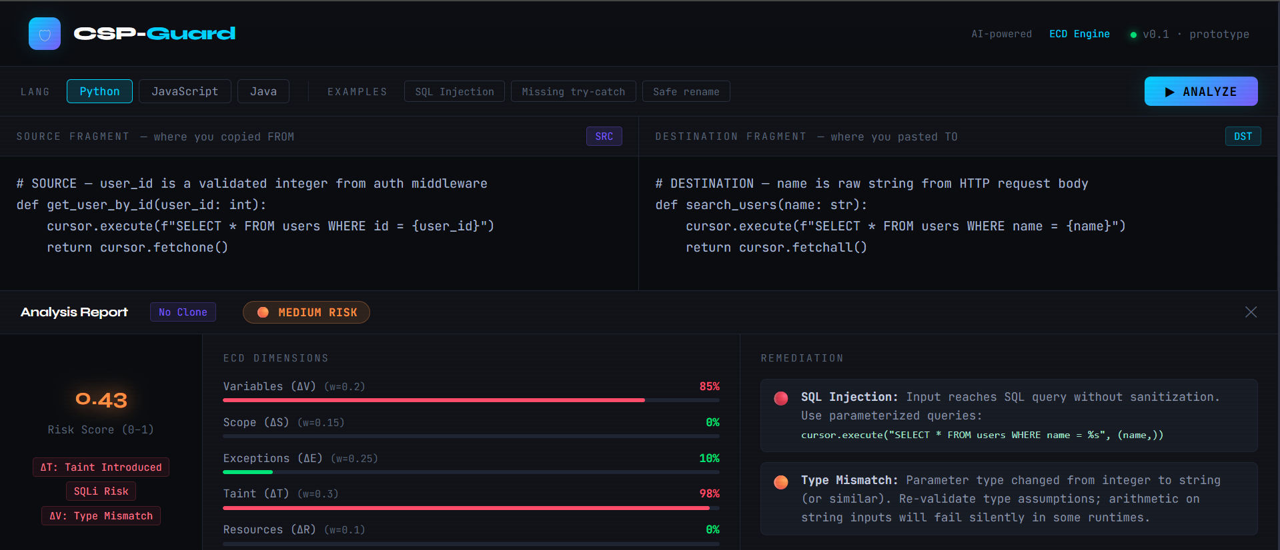
Functional prototype with Web page
Risk analysis output with scoring and remediation (screenshot attached)
Successfully executed test scenarios validating system behavior

medium risk Shows: Taint + Resource + Execution
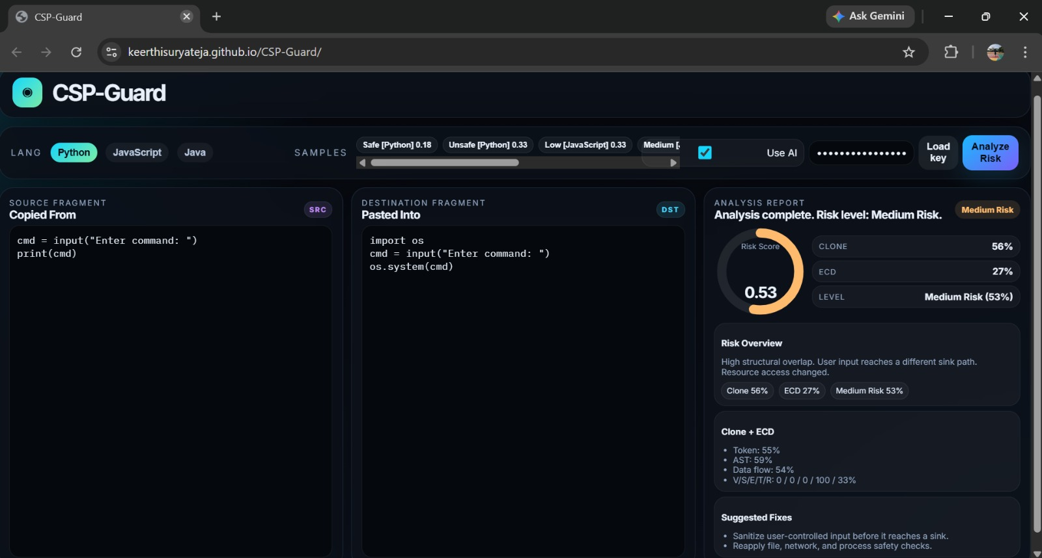
This photo displays a sample analysis result categorized as “Medium Risk.” It highlights factors like taint presence, resource conflicts, and execution differences. Numerical values or percentages indicate severity levels. The system also suggests improvements such as validation or safer coding practices.

HighRisk
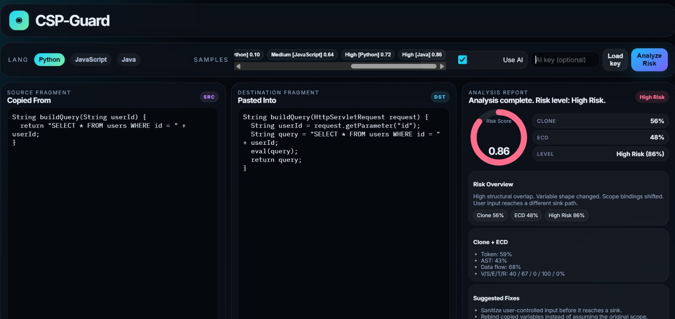
This image represents a scenario where the system detects a high-risk code reuse. It shows strong context mismatches and potential vulnerabilities like unsafe inputs. The output emphasizes critical warnings. It visually alerts users to take immediate corrective actions.

UnSafe
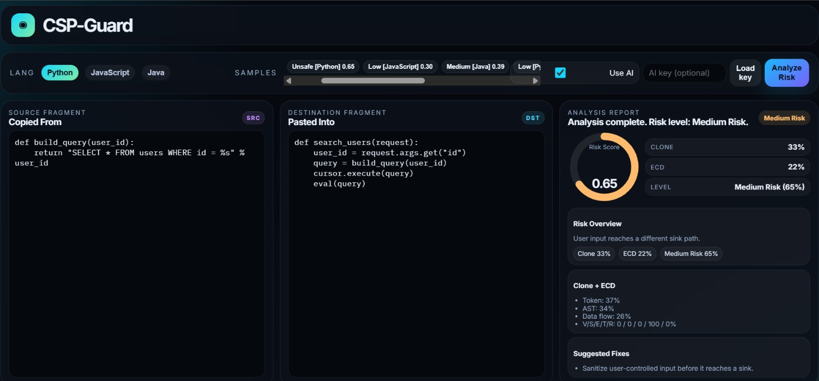
This image represents a case where the system detects unsafe code reuse. Significant differences in execution context, such as taint introduction, missing exception handling, or variable mismatches, are identified. These inconsistencies increase the risk level. The system assigns a high risk score and highlights potential vulnerabilities.

Safe
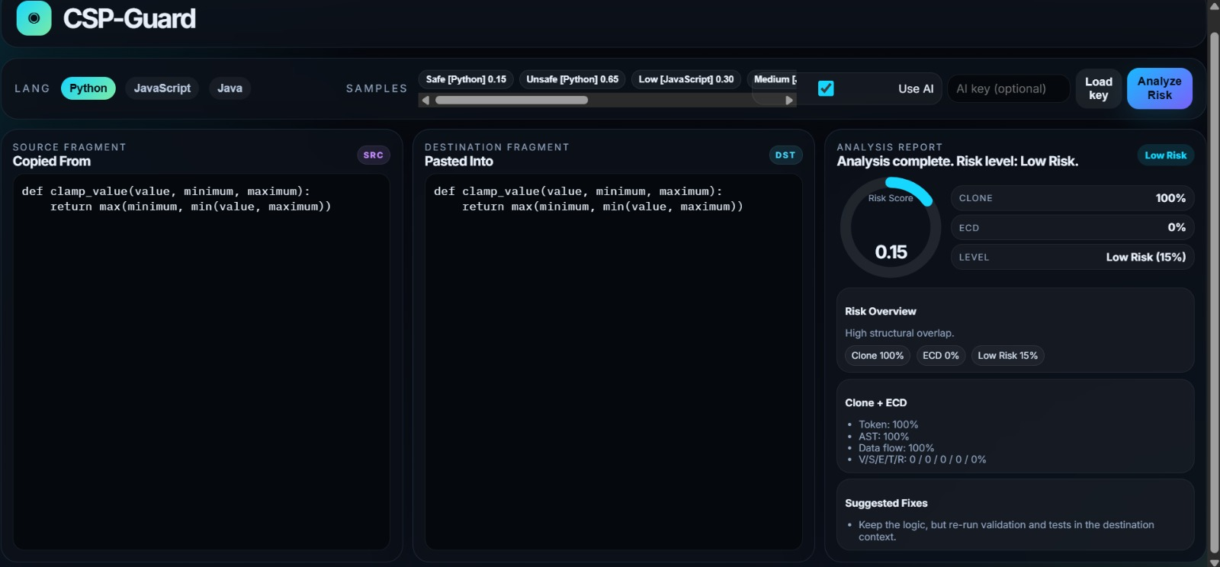
This image shows a scenario where the reused code is classified as safe by the CSP-Guard system. The analysis indicates minimal or no context differences between source and destination environments. Key factors like variables, taint flow, exception handling, and resource usage are consistent. The system assigns a low risk score, confirming secure code reuse.

Website: https://github.com/keerthisuryateja/CSP-Guard

- Briefly state when and how you first conceived this idea?
It came into existence during an academic study regarding software flaws and code reuse, conducted in 2026, as an understanding of shortcomings within existing code clones and static analysis techniques.

- Have you sold, offered for sale, publicly used or published anything related to this invention? If yes, please briefly explain the dates and circumstances. List those individuals to whom you have revealed your invention. Were non-discloser documents signed prior to discloser in each case? Please state any deadlines of which you may be aware for filing an application on this invention.
No.

- Include any reasons that your invention would not have been obvious to someone of average skill in the art.
Previous approaches handle clone detection and security as separate concerns, whereas CSP-Guard introduces the concept of Execution Context Delta, which is absent in earlier systems. It integrates multiple factors such as variables, taint analysis, and exception handling into a single unified risk assessment framework, and provides risk scores that are both interpretable and probabilistic in nature.

- Additional comments by inventor (if you want to give more details out of scope of this IDF).
This invention can be expanded to use AI-powered adaptive learning algorithms and dynamic runtime analysis to increase precision and expand its usefulness.

- Drawings/Flowchart/Table

Risk Scoring Graph
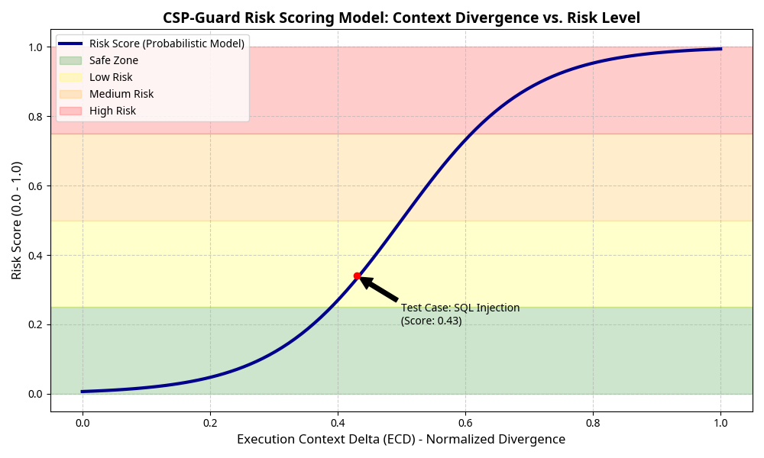

The graph visualizes how risk levels change based on context differences (ECD values). It typically shows increasing risk from Safe to High Risk as divergence increases. Different regions or color zones classify risk categories. This helps users quickly interpret how code variations impact security.

Component Architecture Diagram
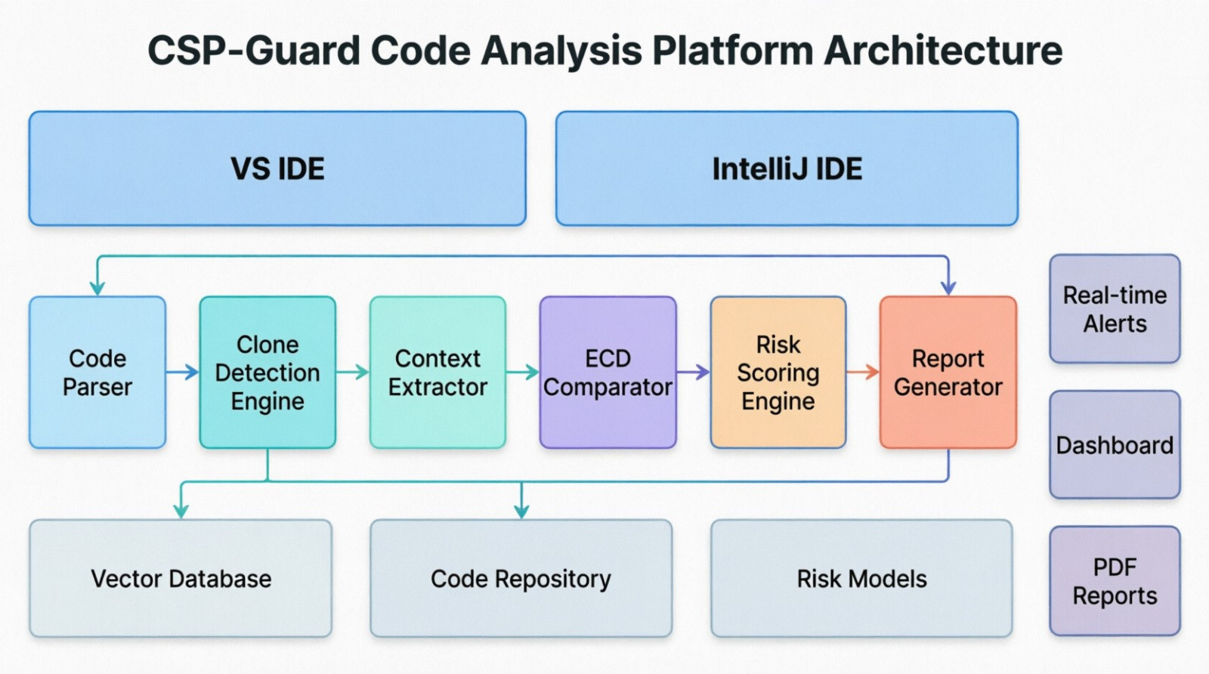
This image represents the internal structure of the CSP-Guard system. It highlights key components like the parser, detection engine, context extractor, ECD comparator, and risk scoring module. Each component is interconnected, showing how they collaborate to perform analysis. The diagram provides a clear view of system design and modular functionality.
CSP-Guard System Workflow and CI/CD Integration Diagram
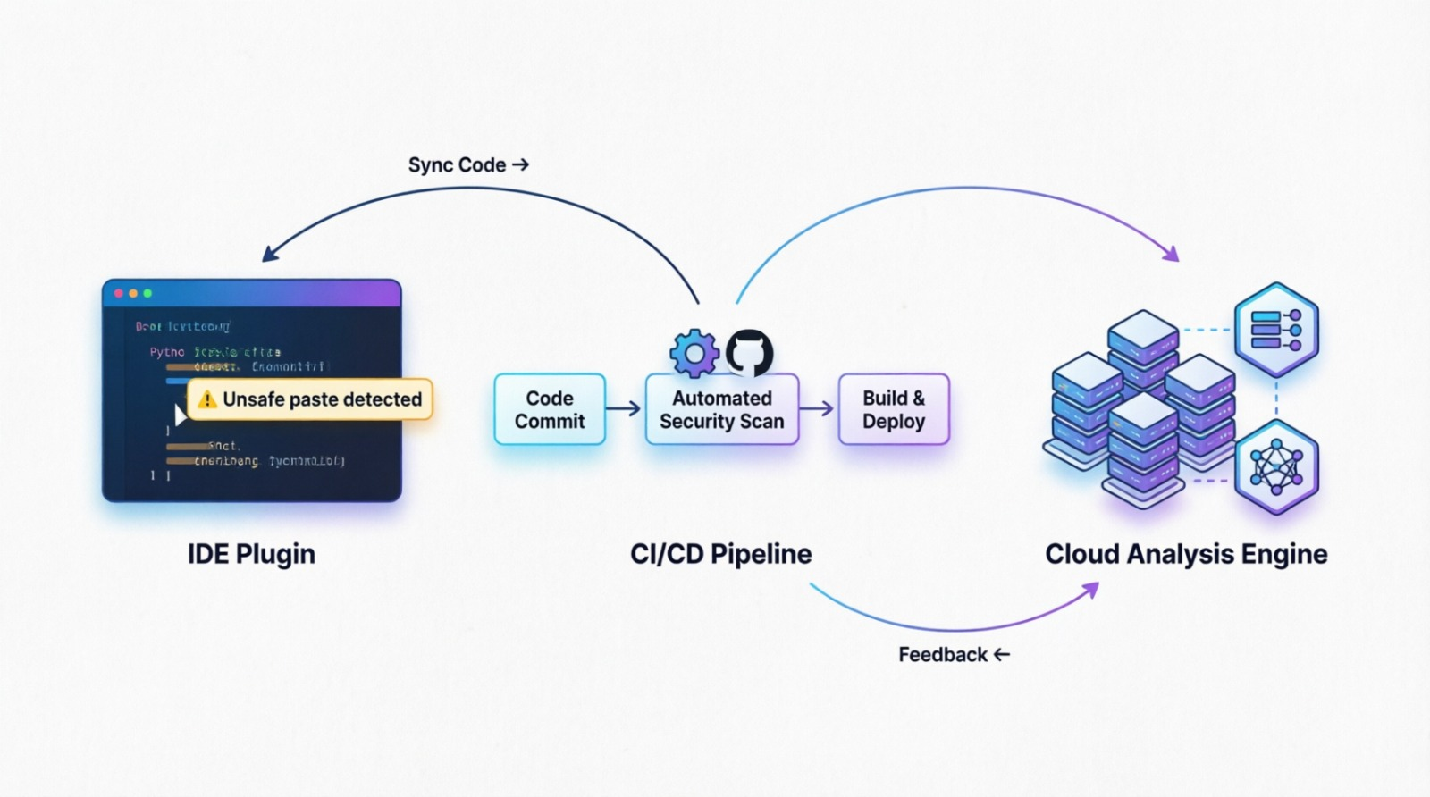
This diagram illustrates the end-to-end workflow of the CSP-Guard system integrated with development environments. It shows how unsafe code is detected through an IDE plugin, followed by automated security scanning in the CI/CD pipeline. The system then performs analysis in the cloud engine and provides feedback. This ensures continuous and real-time security assessment during development.

Form Submitted by:
Name- S Naresh Kumar
Contact No: 9866000203

